**Research and Development Document**

**ON**

**Azure Virtual Network**





**By**

**Anirudh Sharma**

**(CT_CSI_CI_66)**

**Under**

**Celebal Summer Internship**

**in**

**Cloud Infra & Security**

**Table of Contents**

**Microsoft Azure………………………………………………………………………………………** **3**

Creating an azure account …………………………………………………………………………………………………...3

**Azure Virtual Network………………………………………………………………………………..** **4**

**Components of Azure Virtual Network………………………………………………………………………………………**5

CIDR Range.Subnets,Network Security Groups,Vnet Peering……...……………………………………….……………..6

**Creating a Virtual Network………………………………………………………………………..……………………...…6**

**Creating a Virtual Machine…….……………………………………………………………………………………………9**

**Types of Virtual Machine……………………………………………………………………………………………………11**

**References……………………………………………………………………………………………13**

**Microsoft Azure**

Azure marked a pivotal shift from on-premises datacenters to cloud computing. It offers businesses a global network of datacenters maintained and managed by Microsoft; Azure reduces the time and expense associated with maintaining on-premises infrastructure. Azure offers extensive capabilities that go beyond simplifying infrastructure management. With comprehensive AI, data, and application services that work together, Azure delivers a unified approach to cloud computing that’s unique in the industry. Its open, flexible cloud platform is designed to support each company’s business strategy and stage of AI transformation.

**Creating an account of Microsoft Azure:**

1. **Sign-In with your Microsoft Account ( If you dont have one, create it):**

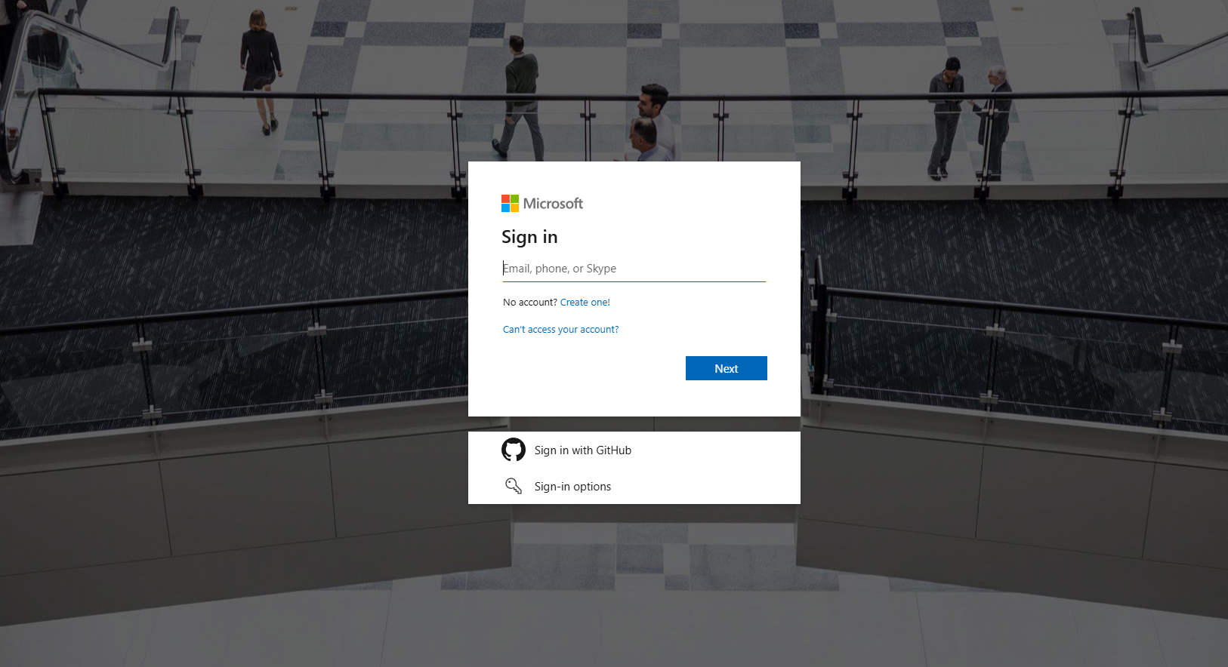

1. **Add your Credit/Debit Card Details (used for billing of the services used)**

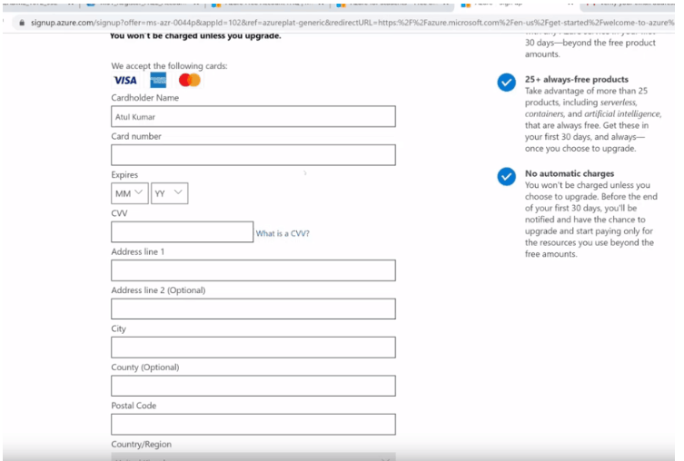

1. **Set up your subscription (Free for 12 months in my case)**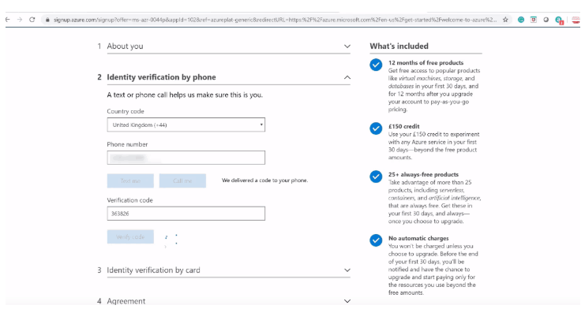
2. **Exploring Azure Portal**

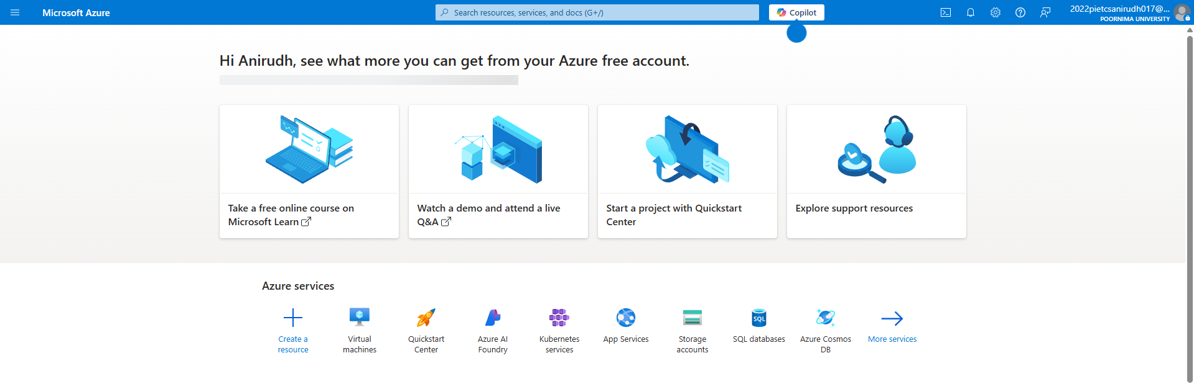

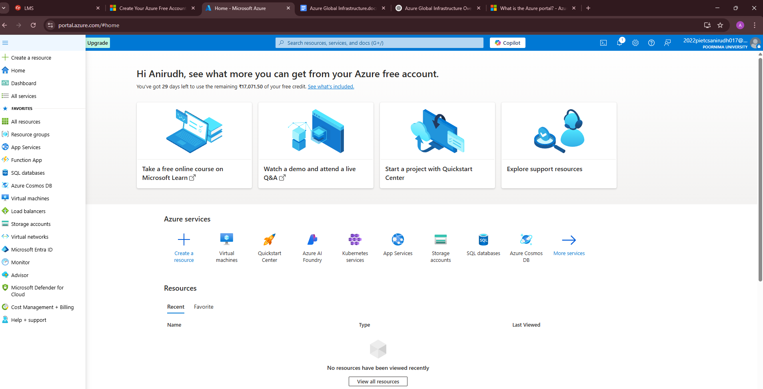

**Azure Portal Snapshot**

**Azure Virtual Network**

Azure Virtual Network is a service that provides the fundamental building block for your private network in Azure. An instance of the service or a virtual network enables many types of Azure resources to securely communicate with each other, the internet, and on-premises networks. All resources in a virtual network can communicate outbound with the internet, by default. We can also use a public IP address or public load balancer to manage your outbound connections. We can communicate inbound with a resource by assigning a public IP address or a public load balancer.

**Components of Azure Virtual Network:**

1. Classless Inter-Domain Routing (CIDR) Range.
2. Subnets
3. Network Security Groups
4. Vnet Peering

**Classless Inter-Domain Routing (CIDR) Range:**

When creating a Virtual Network, specifying the address space is the most critical configuration. This is the IP range for the entire network that will be divided into subnets. As you create your Virtual Network, Azure will help to ensure you do not have your address range overlap with other Virtual Networks. In the portal, you’ll have to create a default subnet when you create your Virtual Network, but you can manage subnets by changing the address range of a subnet as well as adding additional subnets. As you create subnets, it’s important to understand some specifics to ensure we have the correct number of IPs for a given subnet.

Azure holds 5 IP addresses for every subnet. The first and last IP in each subnet is reserved for the network identification and for broadcast, respectively. Azure also holds 3 additional addresses for internal use starting from the first address in the subnet.

**Subnets are created using classless internet domain routing (CIDR) blocks of the address space that was designed for the Virtual Network**. As an example, the smallest range you can specify for a subnet is /29, which provides eight IP addresses. The Azure portal makes it easy to create Virtual Networks and subnets, and even tells you how many IP addresses a given CIDR block is.

**Subnets:**

Subnets enable you to segment the virtual network into one or more sub networks and allocate a portion of the virtual network's address space to each subnet. You can then deploy Azure resources in a specific subnet. Just like in a traditional network, subnets allow you to segment your virtual network address space into segments that are appropriate for the organization's internal network. Segmentation improves address allocation efficiency. You can secure resources within subnets using Network Security Groups.

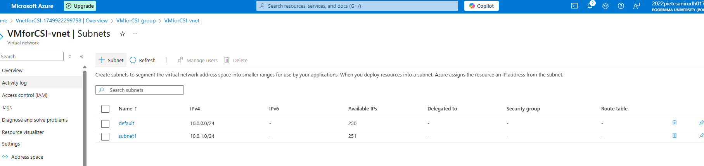

**Network Security Groups:**

Azure Network Security Group (NSG) is a firewall that filters network traffic to and from Azure resources within a virtual network. It allows you to control inbound and outbound traffic based on IP addresses, ports, and protocols.

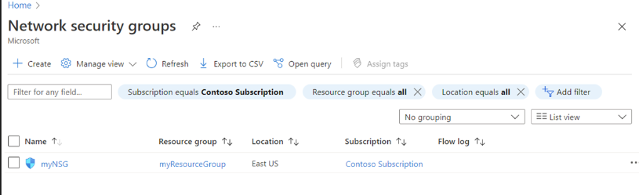

**Vnet(Virtual Network) Peering:**

Virtual network peering enables you to seamlessly connect two or more virtual networks in Azure. The virtual networks appear as one for connectivity purposes. The traffic between virtual machines in peered virtual networks uses the Microsoft backbone infrastructure. Traffic is routed through the Microsoft private network only.

By default, a virtual network is peered with up to 500 other virtual networks. By using the connectivity configuration for Azure Virtual Network Manager, you can increase this limit to peer up to 1,000 virtual networks to a single virtual network. With this larger size, you can create a hub-and-spoke topology with 1,000-spoke virtual networks, for example. You can also create a mesh of 1,000-spoke virtual networks where all spoken virtual networks are directly interconnected.

It is an added flexibility built on top of virtual network peering, where users get an option to choose specific subnets that need to be peered across virtual networks. Users can specify/enter the list of subnets across the virtual networks that they want to peer.

**Creating a Virtual Network**

**Creating Virtual Network (Vnet):**

1. **Fill Basic Details of Vnet**
2. Project details
3. Resource Group
4. Instance Details

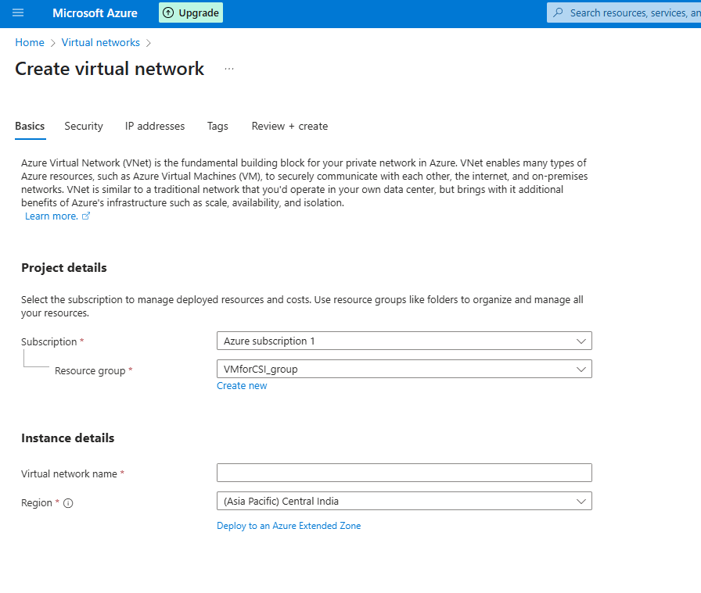

**2. Security :**

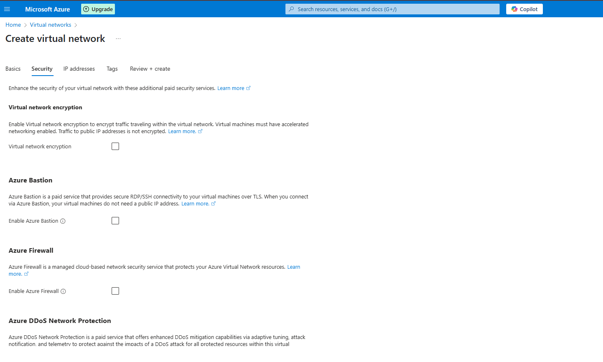

**3 . IP Addressing :** Set IP Address Range (10.0.0.0/16 in my case)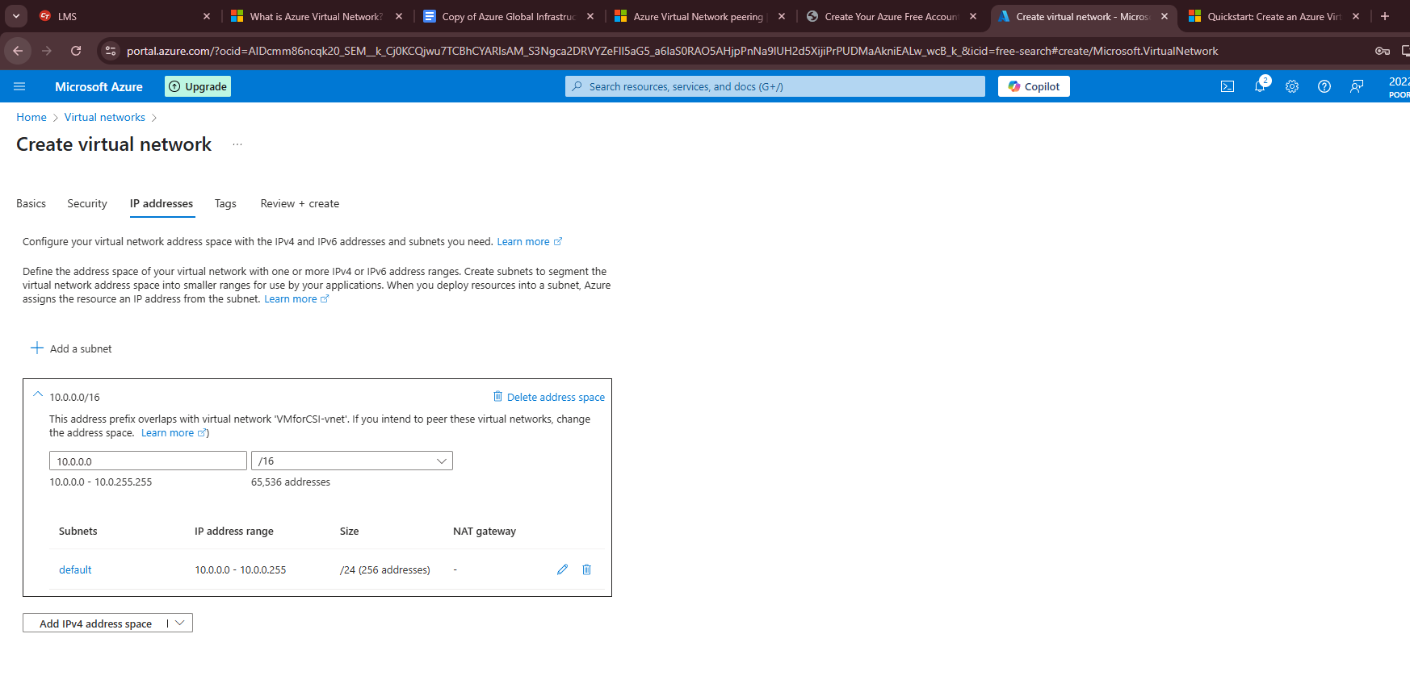

**4. Review and Create :**

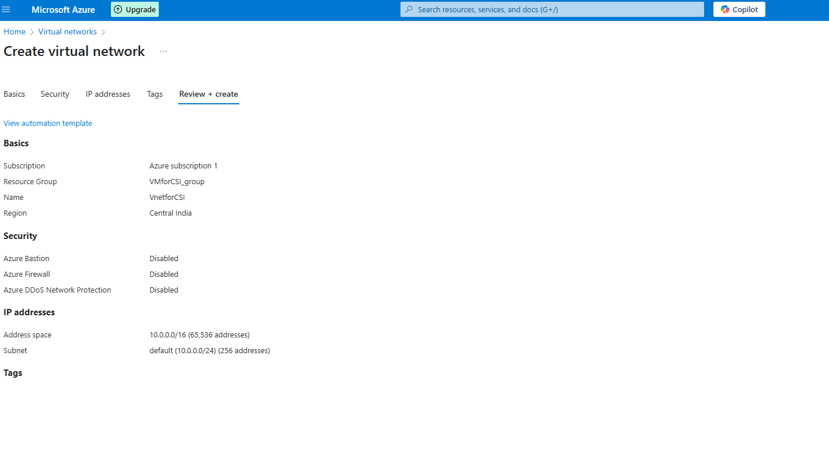

**Resource Group Summary:** 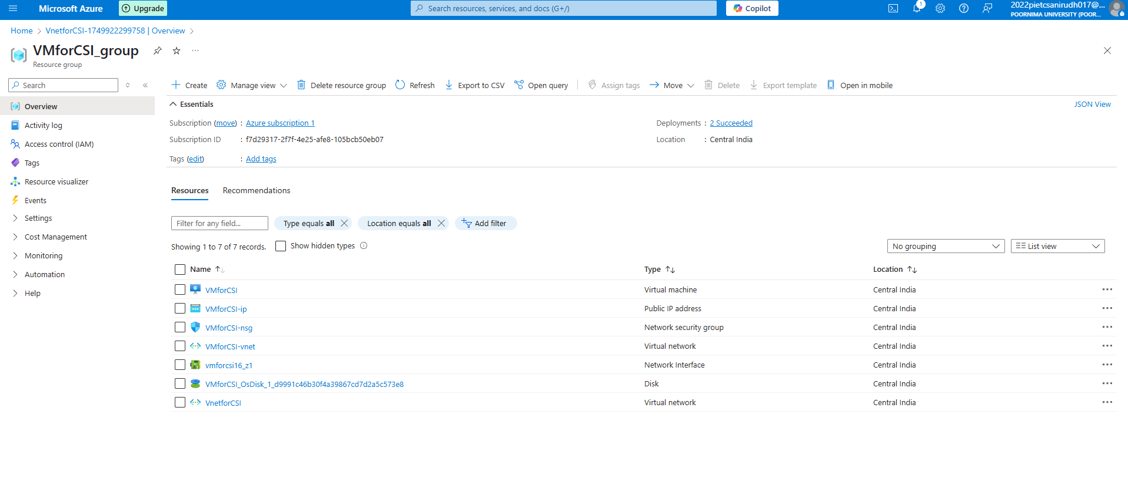

**Creating Virtual Machine**

1. **Fill basic details regarding the VM :**
2. Choose subscription model
3. select / create resource group
4. give VM name & regions
5. create an image (virtualise the VM) on either Microsoft or Ubuntu server.
6. select architecture of VM
7. choose size required for VM ( I have used the free tier eligible storage)
8. Set Authentication for usage of the VM

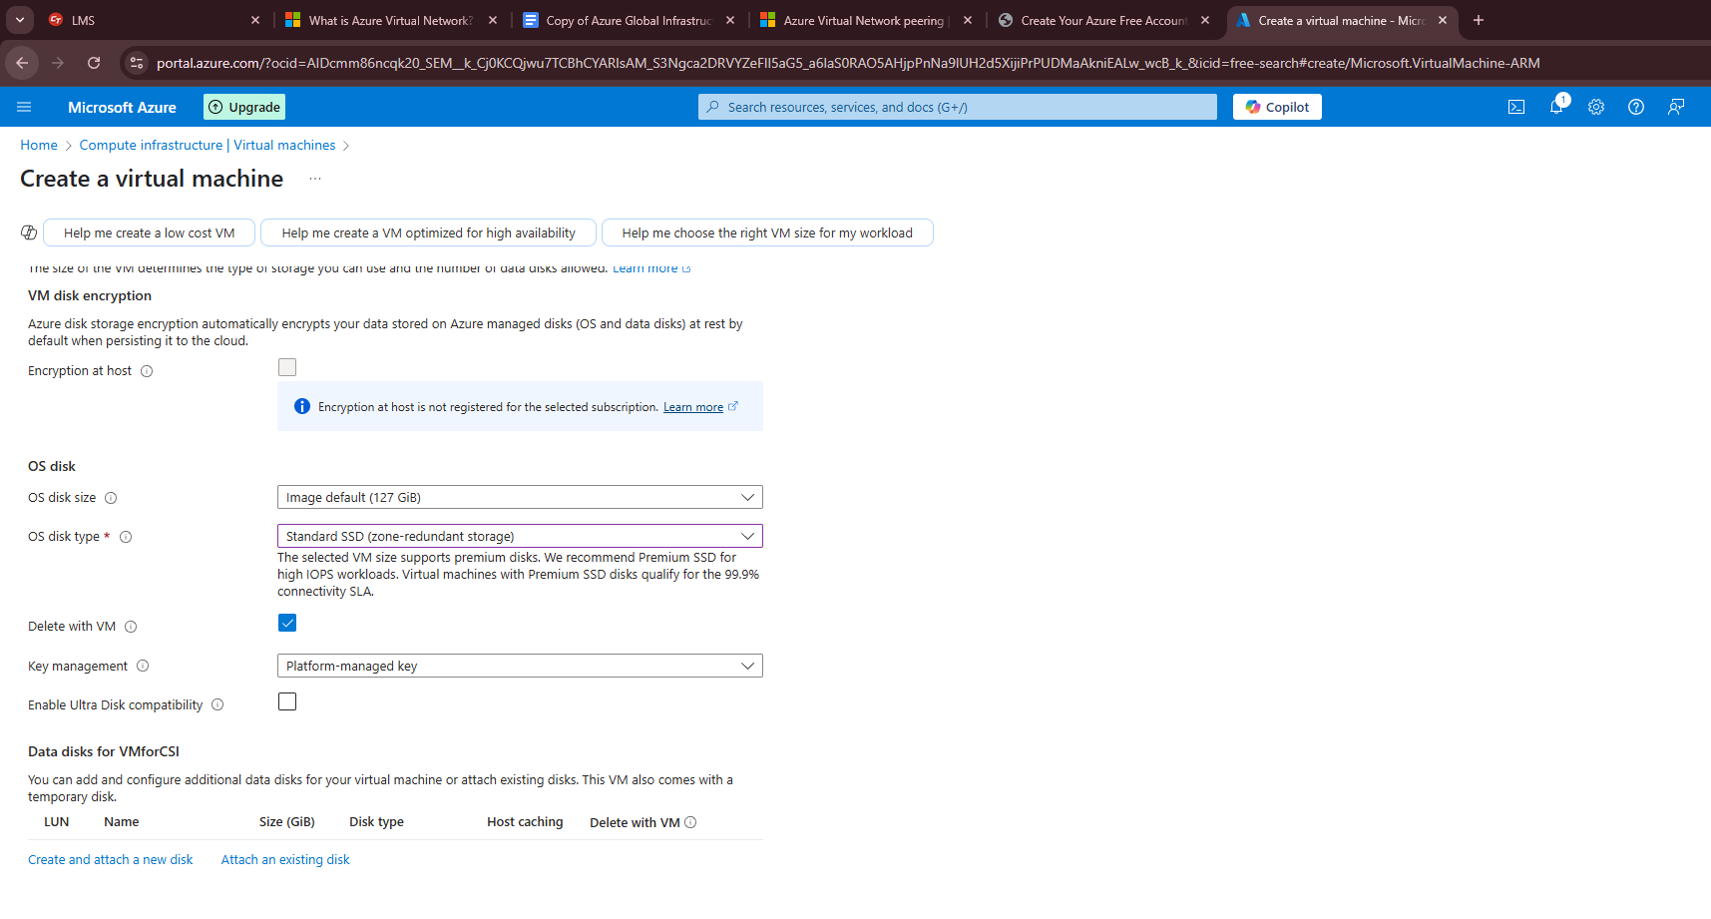

**2. Choose Disk Size and Type:**

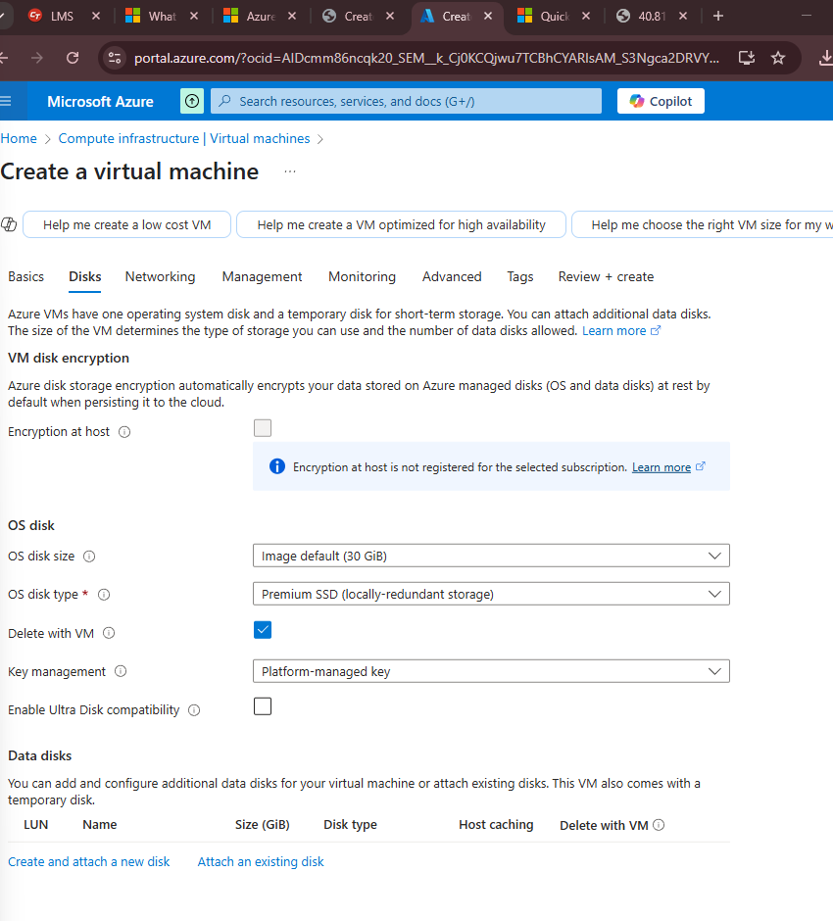

**3 . Set Inbound Ports on Networking Tab:**

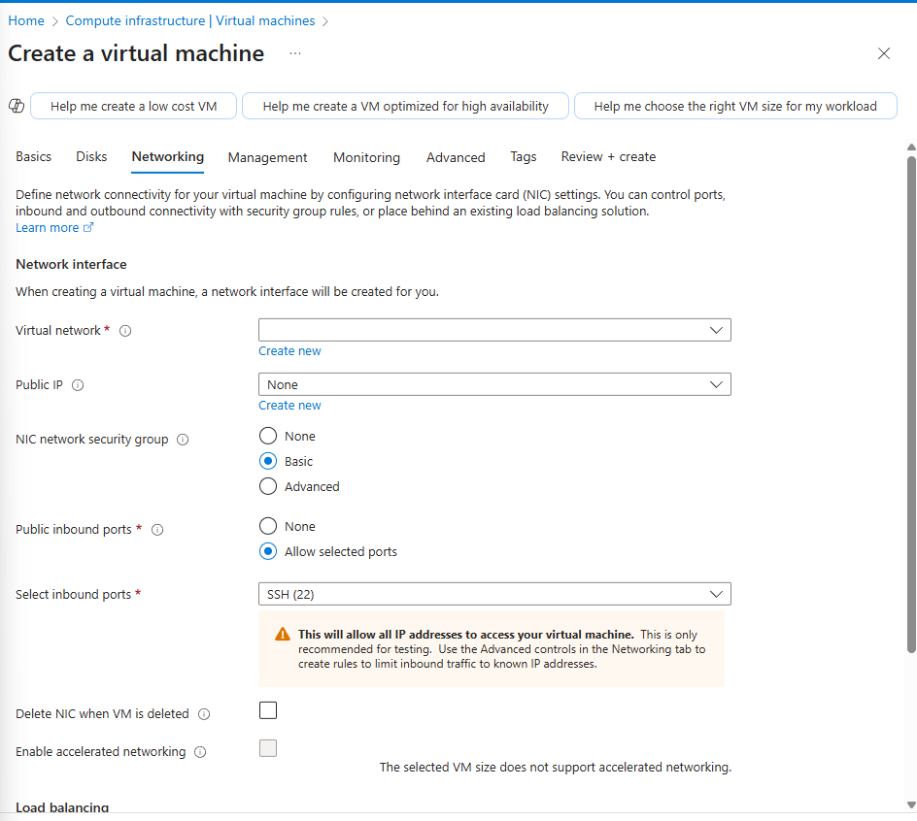

**4. Set other parameters ( Management , Monitoring ,Advanced & Tags)**

**5. Review & Create :**

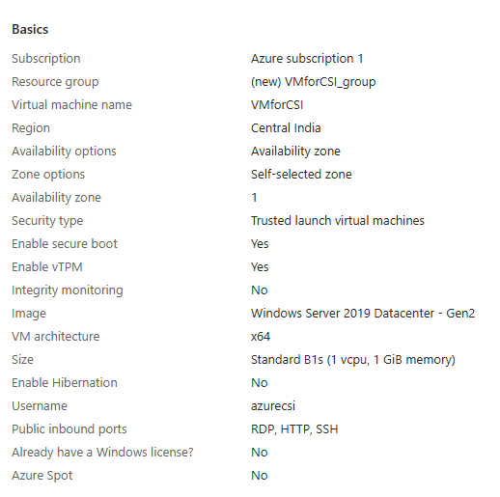

**Types of Azure Virtual Machines**

| **Type** | **Series** | **Description** |
| --- | --- | --- |
| General Purpose | B-series, D-series, E-series | Having a balanced CPU-to-memory ratio, general-purpose virtual machines are appropriate for a variety of workloads, including web servers, small- to medium-sized databases, and development and test environments. |
| Compute Optimized | F-series, H-series, M-series | Compute Optimized VMs have a greater CPU-to-memory ratio, making them suited for CPU-intensive activities including batch processing, video encoding, and high-performance computing. |
| Memory Optimized | M-series, G-series, GS-series | For memory-intensive tasks like big databases, in-memory analytics, and machine learning, Memory Optimized VMs offer a higher ratio of memory to CPU. |
| Storage Optimized | L-series and H-series | Storage The greater storage to CPU and memory ratio offered by optimized VMs makes them appropriate for storage-intensive tasks like big data analytics, data warehousing, and massive NoSQL databases. |

## **Windows Virtual Machines**

### Common Uses:

* .NET/ASP.NET applications
* Windows Server roles (AD, IIS, RDS)
* Microsoft SQL Server
* Remote desktop-based workloads

## **Linux Virtual Machines**

### Common Uses:

* Web servers (Apache, Nginx)
* Docker/Kubernetes hosting
* DevOps tools (Jenkins, Ansible)
* Machine learning & HPC

## **Azure VM Series (Applies to Both Windows & Linux):**

| VM Series | Optimized For | Example VM Sizes | Use Cases |
| --- | --- | --- | --- |
| B-Series | Burstable | B1s, B2ms | Dev/Test, low-traffic websites |
| D-Series | General Purpose | D2s_v3, D4as_v5 | Web apps, enterprise workloads |
| E-Series | Memory Optimized | E4s_v3, E8as_v4 | SQL, SAP HANA, in-memory DBs |
| F-Series | Compute Optimized | F2s, F4s | Batch processing, app servers |
| N-Series | GPU Accelerated | NC6, ND6s | AI/ML, CUDA workloads |
| H-Series | High Performance | HB120rs_v3 | HPC, CFD simulations |
| L-Series | Storage Optimized | L8s_v3 | NoSQL, heavy disk I/O |

**References**

* **Microsoft Azure Documentation**
* **AZURE AZ-900 Fundamentals Documentation**
* **Microsoft Developer Blogs**
* **GeeksForGeeks**